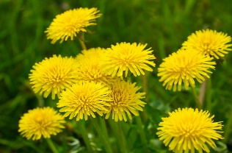
Planned Garden Inspections
When the dandelions start to bloom, we will start inspecting them.
This will probably be in the month of March. Every month until November there will be a garden inspection with the exception of the month of July / August. The gardens where phytoftra is contracted will be inspected in those months.
Where is both attention paid to:
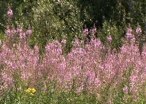
# Dandelion
# Fireweed ---------------
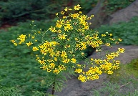
# Ragwort -------------------------------------------

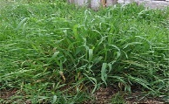
# Sprawl of blackberry bushes
# Nursery grass -----------------------
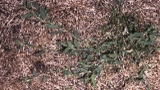
# Pig grass ----------------------------------------------------------
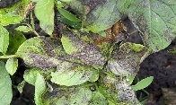
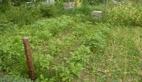
# Phytoftra -----------

# Lots of weeds ---------------------------------

# Provide the garden with a clear number and name. For example ---------
# Loose roofs
# Fence
# Aisles
Anyone who does not comply with the conditions will first receive a letter about what has been found. At the next inspection and it has not yet been done, a fine will be imposed. If fines are handed out 3 times for the same, the board will have to take measures.
The prices of the fines will be announced.
The Garden Inspection Committee,
Rintje Scholtanus and Myrthe Regtop.

